Practice codes

CREATE TABLE employees (

employeeid INT NOT NULL,

name VARCHAR(100) NOT NULL

);

CREATE TABLE orders222 (

name VARCHAR(100) NOT NULL,

age INT NOT NULL,

city VARCHAR(100) NOT NULL

);

INSERT INTO employees (employeeid, name) VALUES (2, NULL);

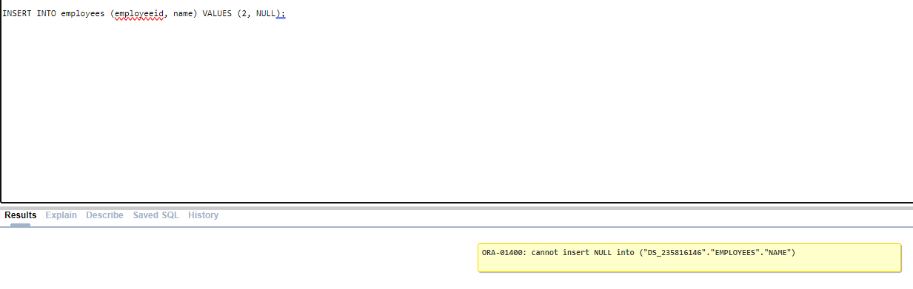

ALTER TABLE orders222 DROP CONSTRAINT;

ALTER TABLE orders222 DROP CONSTRAINT check_age;

ALTER TABLE orders222 ADD CONSTRAINT check_age CHECK (age > 18);

SELECT * FROM orders222;

INSERT INTO orders222 (name, age, city) VALUES ('John Doe', 25, 'Bhopal');

INSERT INTO orders222 (name, age, city) VALUES ('Jane Smith', 30, 'Bhopal');

select * from orders222

INSERT INTO orders222 (name, age, city) VALUES ('Jane Smith', 30, 'Delhi');

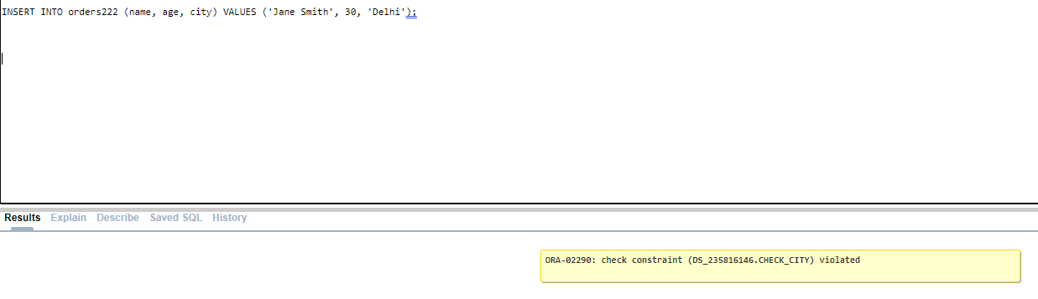

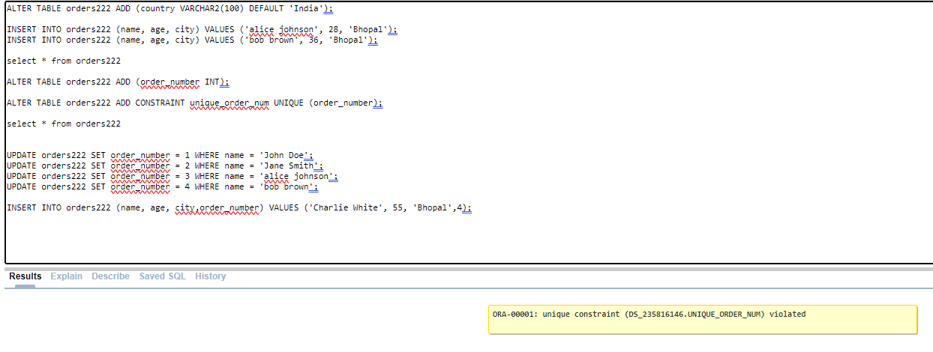

ALTER TABLE orders222 ADD (country VARCHAR2(100) DEFAULT 'India');

INSERT INTO orders222 (name, age, city) VALUES ('alice johnson', 28, 'Bhopal');

INSERT INTO orders222 (name, age, city) VALUES ('bob brown', 36, 'Bhopal');

select * from orders222

ALTER TABLE orders222 ADD (order_number INT);

ALTER TABLE orders222 ADD CONSTRAINT unique_order_num UNIQUE (order_number);

select * from orders222

UPDATE orders222 SET order_number = 1 WHERE name = 'John Doe';

UPDATE orders222 SET order_number = 2 WHERE name = 'Jane Smith';

UPDATE orders222 SET order_number = 3 WHERE name = 'alice johnson';

UPDATE orders222 SET order_number = 4 WHERE name = 'bob brown';

INSERT INTO orders222 (name, age, city,order_number) VALUES ('Charlie White', 55, 'Bhopal',4);



**LAB EXERCISES**

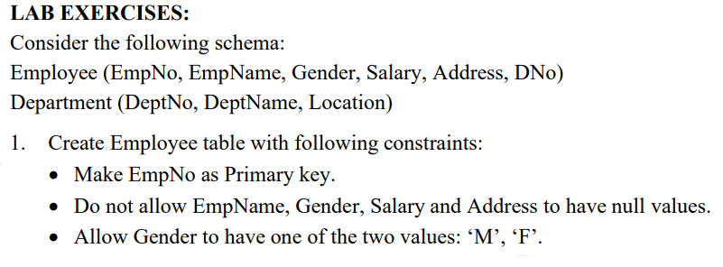

CREATE TABLE Employee (

EmpNo INT PRIMARY KEY,

EmpName VARCHAR(100) NOT NULL,

Gender CHAR(1) NOT NULL,

Salary DECIMAL(10, 2) NOT NULL,

Address VARCHAR(255) NOT NULL,

DNo INT,

CONSTRAINT check_gender CHECK (Gender IN ('M', 'F'))

);

Table created.

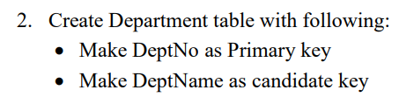

CREATE TABLE Department (

DeptNo INT PRIMARY KEY,

DeptName VARCHAR(100) UNIQUE,

Location VARCHAR(100)

);

Table created.



ALTER TABLE Employee ADD CONSTRAINT foreign_key_dept FOREIGN KEY (DNo) REFERENCES Department(DeptNo);

Table altered.



INSERT INTO Department (DeptNo, DeptName, Location) VALUES (1, 'HR', 'New York');

INSERT INTO Department (DeptNo, DeptName, Location) VALUES (2, 'Finance', 'Los Angeles');

INSERT INTO Department (DeptNo, DeptName, Location) VALUES (3, 'IT', 'Chicago');

select * from Department

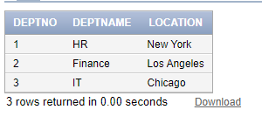

INSERT INTO Employee (EmpNo, EmpName, Gender, Salary, Address, DNo) VALUES (101, 'John Doe', 'M', 50000, '123 Main St', 1);

INSERT INTO Employee (EmpNo, EmpName, Gender, Salary, Address, DNo) VALUES (102, 'Jane Smith', 'F', 55000, '456 Elm St', 2);

INSERT INTO Employee (EmpNo, EmpName, Gender, Salary, Address, DNo) VALUES (103, 'Alice Johnson', 'F', 60000, '789 Oak St', 3);

select * from Employee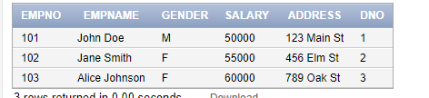



**Violating Gender Constraint**

INSERT INTO Employee (EmpNo, EmpName, Gender, Salary, Address, DNo) VALUES (104, 'Invalid Gender', 'X', 45000, '111 Pine St', 1);



**Insert into Employee with NULL values (Violates NOT NULL Constraints)**

INSERT INTO Employee (EmpNo, EmpName, Gender, Salary, Address, DNo) VALUES (106, NULL, 'M', 48000, '333 Birch St', 2);



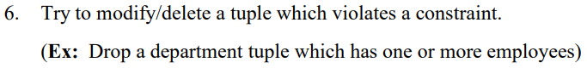**Attempt to Delete a Department with Existing Employees (Violates Foreign Key Constraint)**

DELETE FROM Department WHERE DeptNo = 1;



-- Violate Gender constraint

INSERT INTO Employee (EmpNo, EmpName, Gender, Salary, Address, DNo) VALUES (108, 'Invalid Gender 2', 'X', 45000, '555 Pine St', 1);



ALTER TABLE Employee DROP CONSTRAINT foreign_key_dept;

Table altered

ALTER TABLE Employee ADD CONSTRAINT foreign_key_dept FOREIGN KEY (DNo) REFERENCES Department(DeptNo) ON DELETE CASCADE;

Table altered

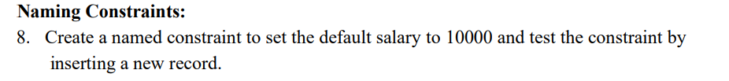

ALTER TABLE Employee DROP COLUMN Salary;

ALTER TABLE Employee ADD Salary DECIMAL(10, 2) DEFAULT 10000;

INSERT INTO Employee (EmpNo, EmpName, Gender, Address, DNo) VALUES (110, 'New Employee', 'M', '777 Maple St', 2);

select * from Employee

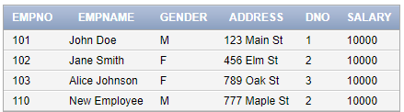

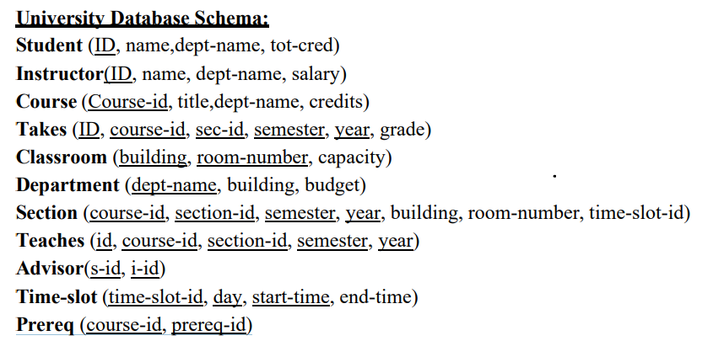

CREATE TABLE Student (

ID INT PRIMARY KEY,

name VARCHAR(100) NOT NULL,

dept_name VARCHAR(100) NOT NULL,

tot_cred INT

);

Table created.

CREATE TABLE Instructor (

ID INT PRIMARY KEY,

name VARCHAR(100) NOT NULL,

dept_name VARCHAR(100) NOT NULL,

salary DECIMAL(10, 2)

);

CREATE TABLE Course (

course_id INT PRIMARY KEY,

title VARCHAR(100) NOT NULL,

dept_name VARCHAR(100) NOT NULL,

credits INT

);

CREATE TABLE Takes (

ID INT,

course_id INT,

sec_id INT,

semester VARCHAR(10),

year INT,

grade CHAR(2),

PRIMARY KEY (ID, course_id, sec_id, semester, year)

);

CREATE TABLE Classroom (

building VARCHAR(50),

room_number INT,

capacity INT,

PRIMARY KEY (building, room_number)

);

CREATE TABLE Department (

dept_name VARCHAR(100) PRIMARY KEY,

building VARCHAR(50),

budget DECIMAL(12, 2)

);

CREATE TABLE Section (

course_id INT,

section_id INT,

semester VARCHAR(10),

year INT,

building VARCHAR(50),

room_number INT,

time_slot_id INT,

PRIMARY KEY (course_id, section_id, semester, year)

);

CREATE TABLE Teaches (

id INT,

course_id INT,

section_id INT,

semester VARCHAR(10),

year INT,

PRIMARY KEY (id, course_id, section_id, semester, year)

);

CREATE TABLE Advisor (

s_id INT,

i_id INT,

PRIMARY KEY (s_id, i_id)

);

CREATE TABLE Time_slot (

time_slot_id INT PRIMARY KEY,

day VARCHAR2(10),

start_time VARCHAR2(5),

end_time VARCHAR2(5)

);

CREATE TABLE Prereq (

course_id INT,

prereq_id INT,

PRIMARY KEY (course_id, prereq_id)

);

-- Insert Values into Student Table

INSERT INTO Student (ID, name, dept_name, tot_cred) VALUES (1, 'Alice Johnson', 'CSE', 30);

INSERT INTO Student (ID, name, dept_name, tot_cred) VALUES (2, 'Bob Brown', 'ECE', 28);

INSERT INTO Student (ID, name, dept_name, tot_cred) VALUES (3, 'Charlie Davis', 'ME', 25);

-- Insert Values into Instructor Table

INSERT INTO Instructor (ID, name, dept_name, salary) VALUES (101, 'Prof. John Smith', 'CSE', 75000.00);

INSERT INTO Instructor (ID, name, dept_name, salary) VALUES (102, 'Prof. Jane Doe', 'ECE', 80000.00);

INSERT INTO Instructor (ID, name, dept_name, salary) VALUES (103, 'Prof. Alan Brown', 'ME', 70000.00);

-- Insert Values into Course Table

INSERT INTO Course (course_id, title, dept_name, credits) VALUES (501, 'Data Structures', 'CSE', 3);

INSERT INTO Course (course_id, title, dept_name, credits) VALUES (502, 'Circuit Theory', 'ECE', 3);

INSERT INTO Course (course_id, title, dept_name, credits) VALUES (503, 'Thermodynamics', 'ME', 3);

-- Insert Values into Takes Table

INSERT INTO Takes (ID, course_id, sec_id, semester, year, grade) VALUES (1, 501, 1, 'Fall', 2023, 'A');

INSERT INTO Takes (ID, course_id, sec_id, semester, year, grade) VALUES (2, 502, 1, 'Spring', 2024, 'B');

INSERT INTO Takes (ID, course_id, sec_id, semester, year, grade) VALUES (3, 503, 1, 'Summer', 2024, 'A');

-- Insert Values into Classroom Table

INSERT INTO Classroom (building, room_number, capacity) VALUES ('Building A', 101, 50);

INSERT INTO Classroom (building, room_number, capacity) VALUES ('Building B', 202, 100);

INSERT INTO Classroom (building, room_number, capacity) VALUES ('Building C', 303, 75);

-- Insert Values into Departments Table

INSERT INTO Departments (dept_name, building, budget) VALUES ('CSE', 'Building A', 500000.00);

INSERT INTO Departments (dept_name, building, budget) VALUES ('ECE', 'Building B', 600000.00);

INSERT INTO Departments (dept_name, building, budget) VALUES ('ME', 'Building C', 700000.00);

-- Insert Values into Section Table

INSERT INTO Section (course_id, section_id, semester, year, building, room_number, time_slot_id) VALUES (501, 1, 'Fall', 2023, 'Building A', 101, 1);

INSERT INTO Section (course_id, section_id, semester, year, building, room_number, time_slot_id) VALUES (502, 1, 'Spring', 2024, 'Building B', 202, 2);

INSERT INTO Section (course_id, section_id, semester, year, building, room_number, time_slot_id) VALUES (503, 1, 'Summer', 2024, 'Building C', 303, 3);

-- Insert Values into Teaches Table

INSERT INTO Teaches (id, course_id, section_id, semester, year) VALUES (101, 501, 1, 'Fall', 2023);

INSERT INTO Teaches (id, course_id, section_id, semester, year) VALUES (102, 502, 1, 'Spring', 2024);

INSERT INTO Teaches (id, course_id, section_id, semester, year) VALUES (103, 503, 1, 'Summer', 2024);

-- Insert Values into Advisor Table

INSERT INTO Advisor (s_id, i_id) VALUES (1, 101);

INSERT INTO Advisor (s_id, i_id) VALUES (2, 102);

INSERT INTO Advisor (s_id, i_id) VALUES (3, 103);

-- Insert Values into Time_slot Table

INSERT INTO Time_slot (time_slot_id, day, start_time, end_time) VALUES (1, 'Monday', '09:00', '10:00');

INSERT INTO Time_slot (time_slot_id, day, start_time, end_time) VALUES (2, 'Wednesday', '11:00', '12:00');

INSERT INTO Time_slot (time_slot_id, day, start_time, end_time) VALUES (3, 'Friday', '14:00', '15:00');

-- Insert Values into Prereq Table

INSERT INTO Prereq (course_id, prereq_id) VALUES (501, 401);

INSERT INTO Prereq (course_id, prereq_id) VALUES (502, 402);

INSERT INTO Prereq (course_id, prereq_id) VALUES (503, 403);

SELECT * FROM Student;

SELECT * FROM Instructor;

SELECT * FROM Course;

SELECT * FROM Takes;

SELECT * FROM Classroom;

SELECT * FROM Departments;

SELECT * FROM Section;

SELECT * FROM Teaches;

SELECT * FROM Advisor;

SELECT * FROM Time_slot;

SELECT * FROM Prereq;

30 JAN PICS

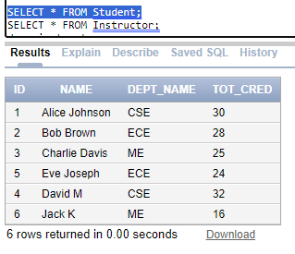

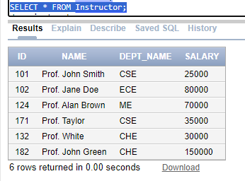

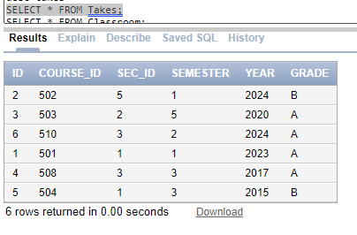

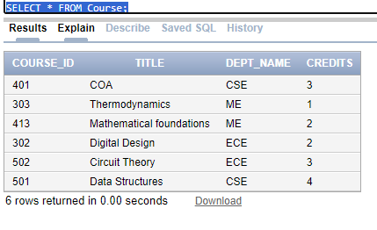

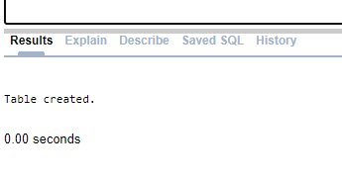

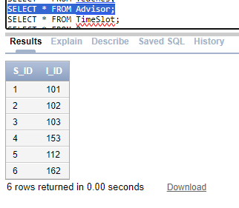

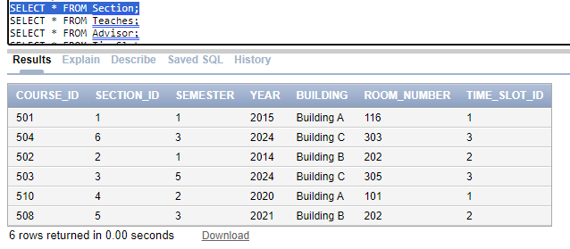

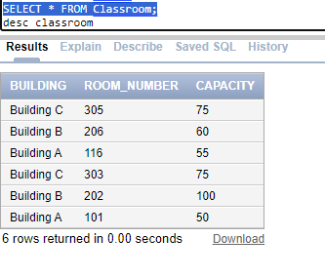

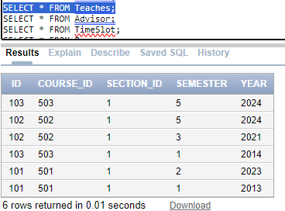

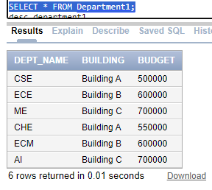

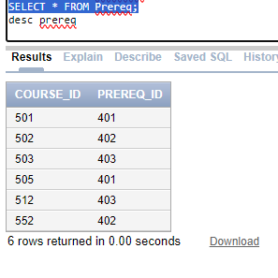

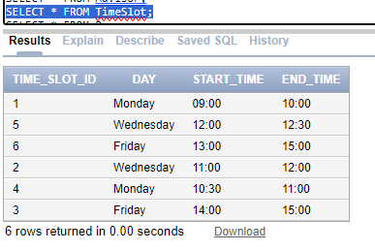

30 JAN FRESH CODE

CREATE TABLE Student (

ID INT PRIMARY KEY,

name VARCHAR(100) NOT NULL,

dept_name VARCHAR(100) NOT NULL,

tot_cred INT

);

CREATE TABLE Instructor (

ID INT PRIMARY KEY,

name VARCHAR(100) NOT NULL,

dept_name VARCHAR(100) NOT NULL,

salary DECIMAL(10, 2)

);

CREATE TABLE Course (

course_id INT PRIMARY KEY,

title VARCHAR(100) NOT NULL,

dept_name VARCHAR(100) NOT NULL,

credits INT

);

CREATE TABLE Takes (

ID INT,

course_id INT,

sec_id INT,

semester VARCHAR(10),

year INT,

grade CHAR(2),

PRIMARY KEY (ID, course_id, sec_id, semester, year)

);

CREATE TABLE Classroom (

building VARCHAR(50),

room_number INT,

capacity INT,

PRIMARY KEY (building, room_number)

);

CREATE TABLE Department1 (

dept_name VARCHAR(100) PRIMARY KEY,

building VARCHAR(50),

budget DECIMAL(12, 2)

);

CREATE TABLE Section (

course_id INT,

section_id INT,

semester VARCHAR(10),

year INT,

building VARCHAR(50),

room_number INT,

time_slot_id INT,

PRIMARY KEY (course_id, section_id, semester, year)

);

CREATE TABLE Teaches (

id INT,

course_id INT,

section_id INT,

semester VARCHAR(10),

year INT,

PRIMARY KEY (id, course_id, section_id, semester, year)

);

CREATE TABLE Advisor (

s_id INT,

i_id INT,

PRIMARY KEY (s_id, i_id)

);

CREATE TABLE TimeSlot (

time_slot_id INT PRIMARY KEY,

day VARCHAR2(10),

start_time VARCHAR2(5),

end_time VARCHAR2(5)

);

CREATE TABLE Prereq (

course_id INT,

prereq_id INT,

PRIMARY KEY (course_id, prereq_id)

);

INSERT INTO Student (ID, name, dept_name, tot_cred) VALUES (1, 'Alice Johnson', 'CSE', 30);

INSERT INTO Student (ID, name, dept_name, tot_cred) VALUES (2, 'Bob Brown', 'ECE', 28);

INSERT INTO Student (ID, name, dept_name, tot_cred) VALUES (3, 'Charlie Davis', 'ME', 25);

INSERT INTO Student (ID, name, dept_name, tot_cred) VALUES (4, 'David M', 'CSE', 32);

INSERT INTO Student (ID, name, dept_name, tot_cred) VALUES (5, 'Eve Joseph', 'ECE', 24);

INSERT INTO Student (ID, name, dept_name, tot_cred) VALUES (6, 'Jack K', 'ME', 16);

-- Insert Values into Instructor Table

INSERT INTO Instructor (ID, name, dept_name, salary) VALUES (101, 'Prof. John Smith', 'CSE', 25000.00);

INSERT INTO Instructor (ID, name, dept_name, salary) VALUES (102, 'Prof. Jane Doe', 'ECE', 80000.00);

INSERT INTO Instructor (ID, name, dept_name, salary) VALUES (124, 'Prof. Alan Brown', 'ME', 70000.00);

INSERT INTO Instructor (ID, name, dept_name, salary) VALUES (171, 'Prof. Taylor', 'CSE', 35000.00);

INSERT INTO Instructor (ID, name, dept_name, salary) VALUES (132, 'Prof. White', 'CHE', 30000.00);

INSERT INTO Instructor (ID, name, dept_name, salary) VALUES (182, 'Prof. John Green', 'CHE', 150000.00);

-- Insert Values into Course Table

INSERT INTO Course (course_id, title, dept_name, credits) VALUES (501, 'Data Structures', 'CSE', 4);

INSERT INTO Course (course_id, title, dept_name, credits) VALUES (502, 'Circuit Theory', 'ECE', 3);

INSERT INTO Course (course_id, title, dept_name, credits) VALUES (303, 'Thermodynamics', 'ME', 1);

INSERT INTO Course (course_id, title, dept_name, credits) VALUES (401, 'COA', 'CSE', 3);

INSERT INTO Course (course_id, title, dept_name, credits) VALUES (302, 'Digital Design', 'ECE', 2);

INSERT INTO Course (course_id, title, dept_name, credits) VALUES (413, 'Mathematical foundations', 'ME', 2);

INSERT INTO Takes (ID, course_id, sec_id, semester, year, grade) VALUES (1, 501, 1, '1', 2023, 'A');

INSERT INTO Takes (ID, course_id, sec_id, semester, year, grade) VALUES (2, 502, 5, '1', 2024, 'B');

INSERT INTO Takes (ID, course_id, sec_id, semester, year, grade) VALUES (3, 503, 2, '5', 2020, 'A');

INSERT INTO Takes (ID, course_id, sec_id, semester, year, grade) VALUES (4, 508, 3, '3', 2017, 'A');

INSERT INTO Takes (ID, course_id, sec_id, semester, year, grade) VALUES (5, 504, 1, '3', 2015, 'B');

INSERT INTO Takes (ID, course_id, sec_id, semester, year, grade) VALUES (6, 510, 3, '2', 2024, 'A');

INSERT INTO Classroom (building, room_number, capacity) VALUES ('Building A', 101, 50);

INSERT INTO Classroom (building, room_number, capacity) VALUES ('Building B', 202, 100);

INSERT INTO Classroom (building, room_number, capacity) VALUES ('Building C', 303, 75);

INSERT INTO Classroom (building, room_number, capacity) VALUES ('Building A', 116, 55);

INSERT INTO Classroom (building, room_number, capacity) VALUES ('Building B', 206, 60);

INSERT INTO Classroom (building, room_number, capacity) VALUES ('Building C', 305, 75);

INSERT INTO Department1 (dept_name, building, budget) VALUES ('CSE', 'Building A', 500000.00);

INSERT INTO Department1 (dept_name, building, budget) VALUES ('ECE', 'Building B', 600000.00);

INSERT INTO Department1 (dept_name, building, budget) VALUES ('ME', 'Building C', 700000.00);

INSERT INTO Department1 (dept_name, building, budget) VALUES ('CHE', 'Building A', 550000.00);

INSERT INTO Department1 (dept_name, building, budget) VALUES ('ECM', 'Building B', 600000.00);

INSERT INTO Department1 (dept_name, building, budget) VALUES ('AI', 'Building C', 700000.00);

INSERT INTO Section (course_id, section_id, semester, year, building, room_number, time_slot_id) VALUES (501, 1, '1', 2015, 'Building A', 116, 1);

INSERT INTO Section (course_id, section_id, semester, year, building, room_number, time_slot_id) VALUES (502, 2, '1', 2014, 'Building B', 202, 2);

INSERT INTO Section (course_id, section_id, semester, year, building, room_number, time_slot_id) VALUES (503, 3, '5', 2024, 'Building C', 305, 3);

INSERT INTO Section (course_id, section_id, semester, year, building, room_number, time_slot_id) VALUES (510, 4, '2', 2020, 'Building A', 101, 1);

INSERT INTO Section (course_id, section_id, semester, year, building, room_number, time_slot_id) VALUES (508, 5, '3', 2021, 'Building B', 202, 2);

INSERT INTO Section (course_id, section_id, semester, year, building, room_number, time_slot_id) VALUES (504, 6, '3', 2024, 'Building C', 303, 3);

INSERT INTO Prereq (course_id, prereq_id) VALUES (501, 401);

INSERT INTO Prereq (course_id, prereq_id) VALUES (502, 402);

INSERT INTO Prereq (course_id, prereq_id) VALUES (503, 403);

INSERT INTO Prereq (course_id, prereq_id) VALUES (505, 401);

INSERT INTO Prereq (course_id, prereq_id) VALUES (552, 402);

INSERT INTO Prereq (course_id, prereq_id) VALUES (512, 403);

INSERT INTO TimeSlot (time_slot_id, day, start_time, end_time) VALUES (1, 'Monday', '09:00', '10:00');

INSERT INTO TimeSlot(time_slot_id, day, start_time, end_time) VALUES (2, 'Wednesday', '11:00', '12:00');

INSERT INTO TimeSlot (time_slot_id, day, start_time, end_time) VALUES (3, 'Friday', '14:00', '15:00');

INSERT INTO TimeSlot(time_slot_id, day, start_time, end_time) VALUES (4, 'Monday', '10:30', '11:00');

INSERT INTO TimeSlot(time_slot_id, day, start_time, end_time) VALUES (5, 'Wednesday', '12:00', '12:30');

INSERT INTO TimeSlot (time_slot_id, day, start_time, end_time) VALUES (6, 'Friday', '13:00', '15:00');

-- Insert Values into Teaches Table

INSERT INTO Teaches (id, course_id, section_id, semester, year) VALUES (101, 501, 1, '2', 2023);

INSERT INTO Teaches (id, course_id, section_id, semester, year) VALUES (102, 502, 1, '5', 2024);

INSERT INTO Teaches (id, course_id, section_id, semester, year) VALUES (103, 503, 1, '5', 2024);

INSERT INTO Teaches (id, course_id, section_id, semester, year) VALUES (101, 501, 1, '1', 2013);

INSERT INTO Teaches (id, course_id, section_id, semester, year) VALUES (102, 502, 1, '3', 2021);

INSERT INTO Teaches (id, course_id, section_id, semester, year) VALUES (103, 503, 1, '1', 2014);

-- Insert Values into Advisor Table

INSERT INTO Advisor (s_id, i_id) VALUES (1, 101);

INSERT INTO Advisor (s_id, i_id) VALUES (2, 102);

INSERT INTO Advisor (s_id, i_id) VALUES (3, 103);

INSERT INTO Advisor (s_id, i_id) VALUES (4, 153);

INSERT INTO Advisor (s_id, i_id) VALUES (5, 112);

INSERT INTO Advisor (s_id, i_id) VALUES (6, 162);

SELECT * FROM Student;

SELECT * FROM Instructor;

desc instructor

SELECT * FROM Course;

desc takes

SELECT * FROM Takes;

SELECT * FROM Classroom;

desc classroom

SELECT * FROM Department1;

desc department1

SELECT * FROM Section;

SELECT * FROM Teaches;

SELECT * FROM Advisor;

SELECT * FROM TimeSlot;

SELECT * FROM Prereq;

desc prereq

9. List all Students with names and their department names.

SELECT name, dept_name

FROM Student;

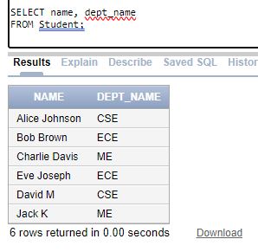

10. List all instructors in CSE department.

SELECT name

FROM Instructor

WHERE dept_name = 'CSE';

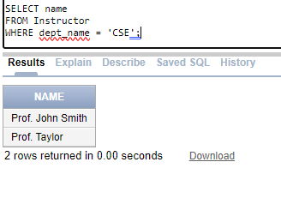

11. Find the names of courses in CSE department which have 3 credits.

SELECT title

FROM Course

WHERE dept_name = 'CSE' AND credits = 3;

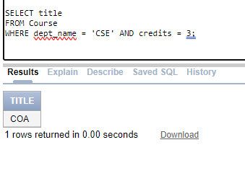

12. For the student with ID 12345 (or any other value), show all course-id and title of all courses registered for by the student.

SELECT Course.course_id, Course.title

FROM Takes

JOIN Course ON Takes.course_id = Course.course_id

WHERE Takes.ID = 1;

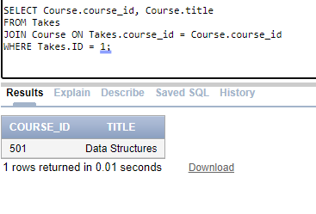

13. List all the instructors whose salary is in between 40000 and 90000. Retrieving records from multiple tables:

SELECT name

FROM Instructor

WHERE salary BETWEEN 40000 AND 90000;

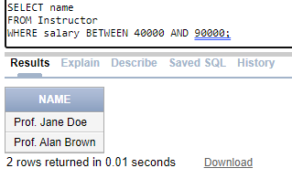

14. Display the IDs of all instructors who have never taught a course.

SELECT ID

FROM Instructor

WHERE ID NOT IN (SELECT DISTINCT ID FROM Teaches);

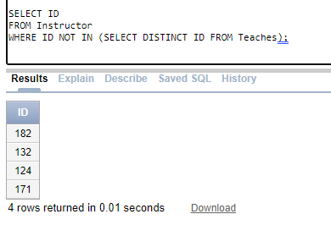

15. Find the student names, course names, and the year, for all students those who have attended classes in room-number 303. Rename and Tuple Variables (Use as in select and from):

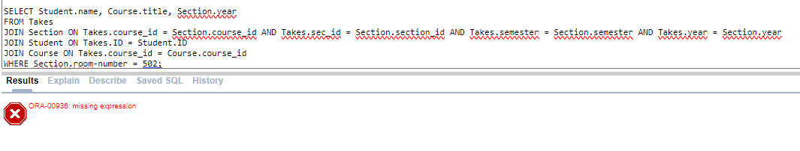

16. For all students who have opted courses in 2024, find their names and course id’s with the attribute course title replaced by c-name.

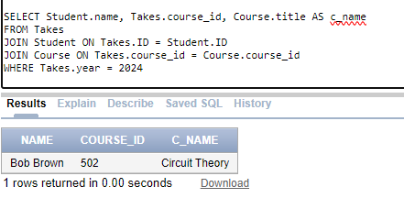

17. Find the names of all instructors whose salary is greater than the salary of at least one instructor of CSE department and salary replaced by inst-salary. String Operations (Use %, _, LIKE):

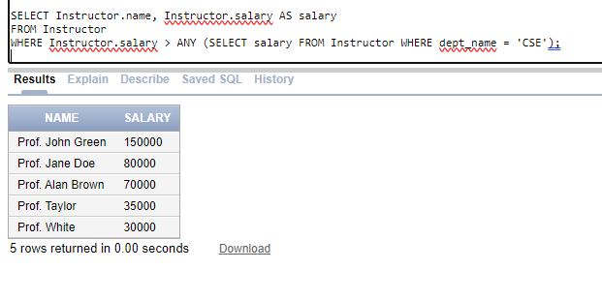

18. Find the names of all instructors whose department name includes the substring ‘ch’. Built-in Functions

SELECT name

FROM Instructor

WHERE dept_name LIKE '%CS%';:

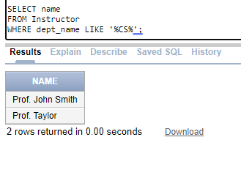

19. List the student names along with the length of the student names.

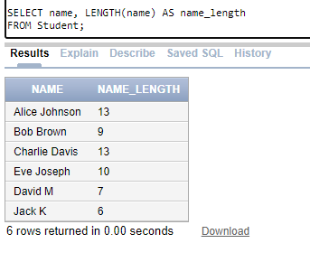

20. List the department names and 3 characters from 3 rd position of each department name

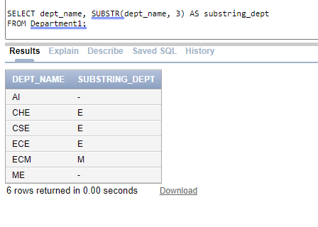

21. List the instructor names in upper case.

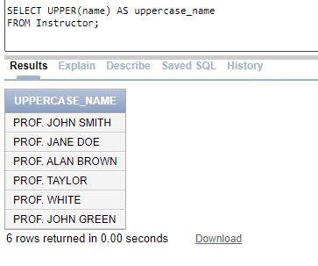

22. Replace NULL with value1(say 0) for a column in any of the table

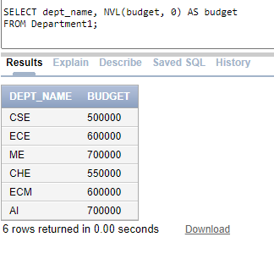

23. Display the salary and salary/3 rounded to nearest hundred from Instructor. Add date of birth column (DOB) to Employee Table. Insert appropriate DOB values for different employees and try the exercise problems given below:

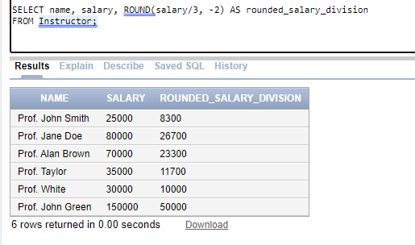

24. Display the birth date of all the employees in the following format: • ‘DD-MON-YYYY’ • ‘DD-MON-YY’ • ‘DD-MM-YY’

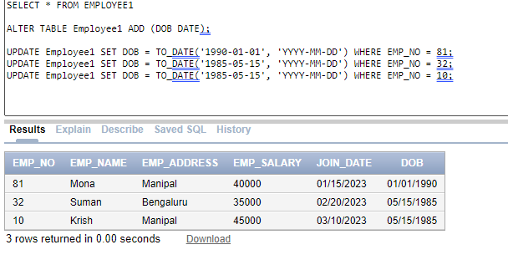

25. List the employee names and the year (fully spelled out) in which they are born • ‘YEAR’ • ‘Year’ • ‘yeaR

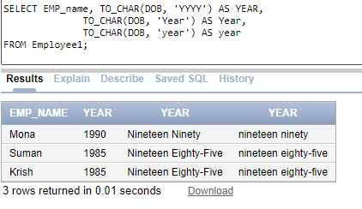

all query codes

SELECT * FROM Student;

SELECT * FROM Instructor;

desc instructor

SELECT * FROM Course;

desc takes

SELECT * FROM Takes;

SELECT * FROM Classroom;

desc classroom

SELECT * FROM Department1;

desc department1

SELECT * FROM Section;

SELECT * FROM Teaches;

SELECT * FROM Advisor;

SELECT * FROM TimeSlot;

SELECT * FROM Prereq;

desc prereq

SELECT name, dept_name

FROM Student;

SELECT name

FROM Instructor

WHERE dept_name = 'CSE';

SELECT title

FROM Course

WHERE dept_name = 'CSE' AND credits = 3;

SELECT Course.course_id, Course.title

FROM Takes

JOIN Course ON Takes.course_id = Course.course_id

WHERE Takes.ID = 1;

SELECT name

FROM Instructor

WHERE salary BETWEEN 40000 AND 90000;

SELECT ID

FROM Instructor

WHERE ID NOT IN (SELECT DISTINCT ID FROM Teaches);

SELECT Student.name, Course.title, Section.year

FROM Takes

JOIN Section ON Takes.course_id = Section.course_id AND Takes.sec_id = Section.section_id AND Takes.semester = Section.semester AND Takes.year = Section.year

JOIN Student ON Takes.ID = Student.ID

JOIN Course ON Takes.course_id = Course.course_id

WHERE Section.room-number = 501;

select * from Section

select * from takes

select * from Course

select * from Student

SELECT Student.name, Takes.course_id, Course.title AS c_name

FROM Takes

JOIN Student ON Takes.ID = Student.ID

JOIN Course ON Takes.course_id = Course.course_id

WHERE Takes.year = 2024

SELECT Instructor.name, Instructor.salary AS salary

FROM Instructor

WHERE Instructor.salary > ANY (SELECT salary FROM Instructor WHERE dept_name = 'CSE');

SELECT name

FROM Instructor

WHERE dept_name LIKE '%CS%';

SELECT name, LENGTH(name) AS name_length

FROM Student;

SELECT dept_name, SUBSTR(dept_name, 3) AS substring_dept

FROM Department1;

SELECT UPPER(name) AS uppercase_name

FROM Instructor;

SELECT dept_name, NVL(budget, 0) AS budget

FROM Department1;

SELECT name, salary, ROUND(salary/3, -2) AS rounded_salary_division

FROM Instructor;

SELECT * FROM EMPLOYEE1

ALTER TABLE Employee1 ADD (DOB DATE);

UPDATE Employee1 SET DOB = TO_DATE('1990-01-01', 'YYYY-MM-DD') WHERE EMP_NO = 81;

UPDATE Employee1 SET DOB = TO_DATE('1985-05-15', 'YYYY-MM-DD') WHERE EMP_NO = 32;

UPDATE Employee1 SET DOB = TO_DATE('1985-05-15', 'YYYY-MM-DD') WHERE EMP_NO = 10;

SELECT EMP_name, TO_CHAR(DOB, 'YYYY') AS YEAR,

TO_CHAR(DOB, 'Year') AS Year,

TO_CHAR(DOB, 'year') AS year

FROM Employee1;